EXECUTION SCREENSHOTS:

1st input:(

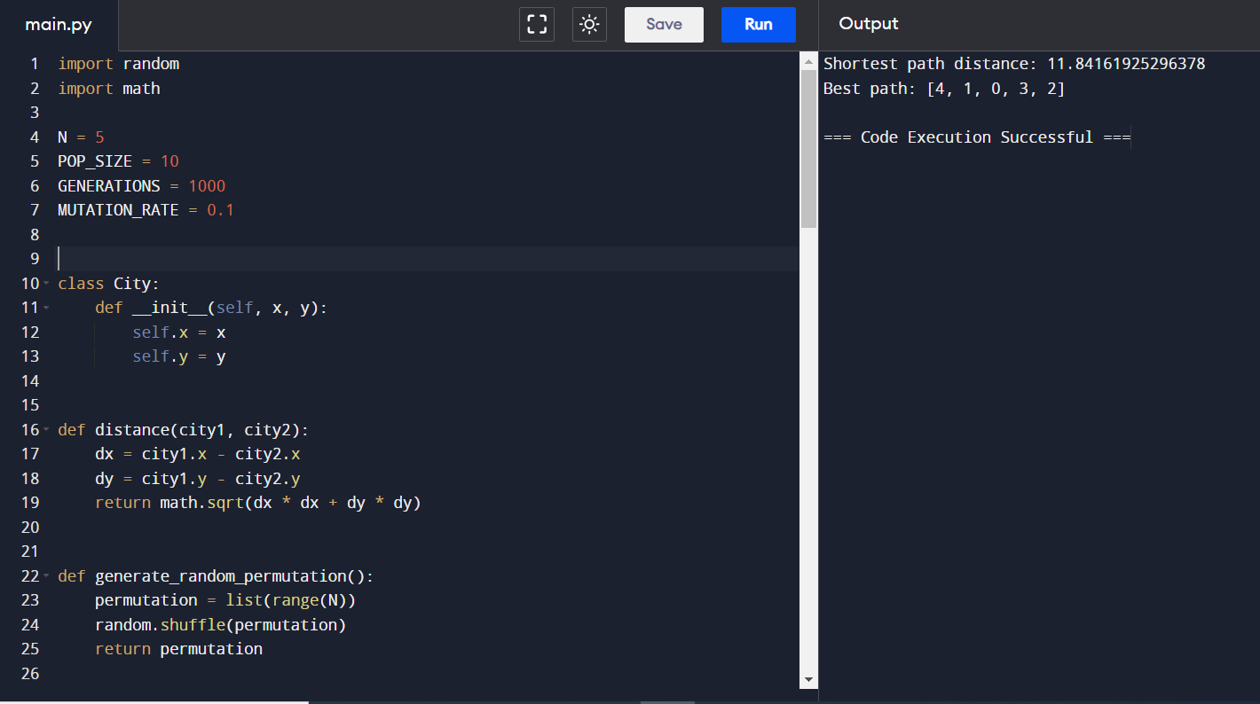

2nd input:(1,0);(1,2);(2,3);(5,3);(5,4)

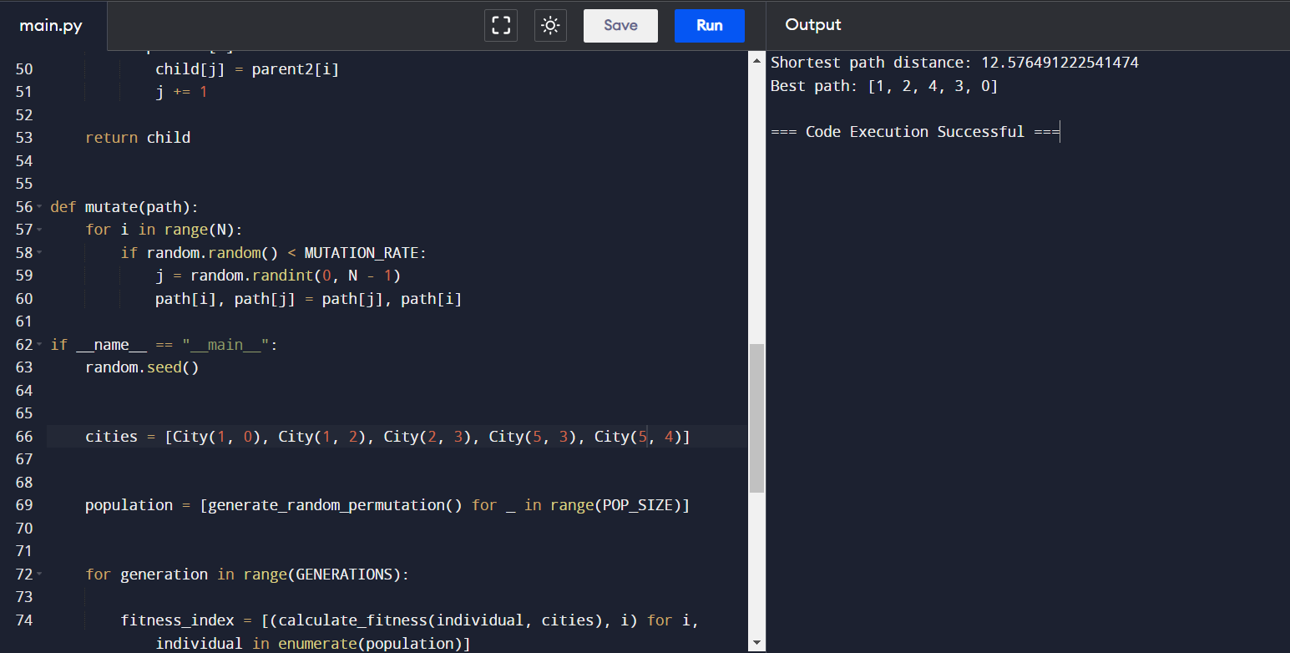

3rd input:(0,0);(2,2);(2,3);(5,5);(4,4)

